Step 1: Set up the React App
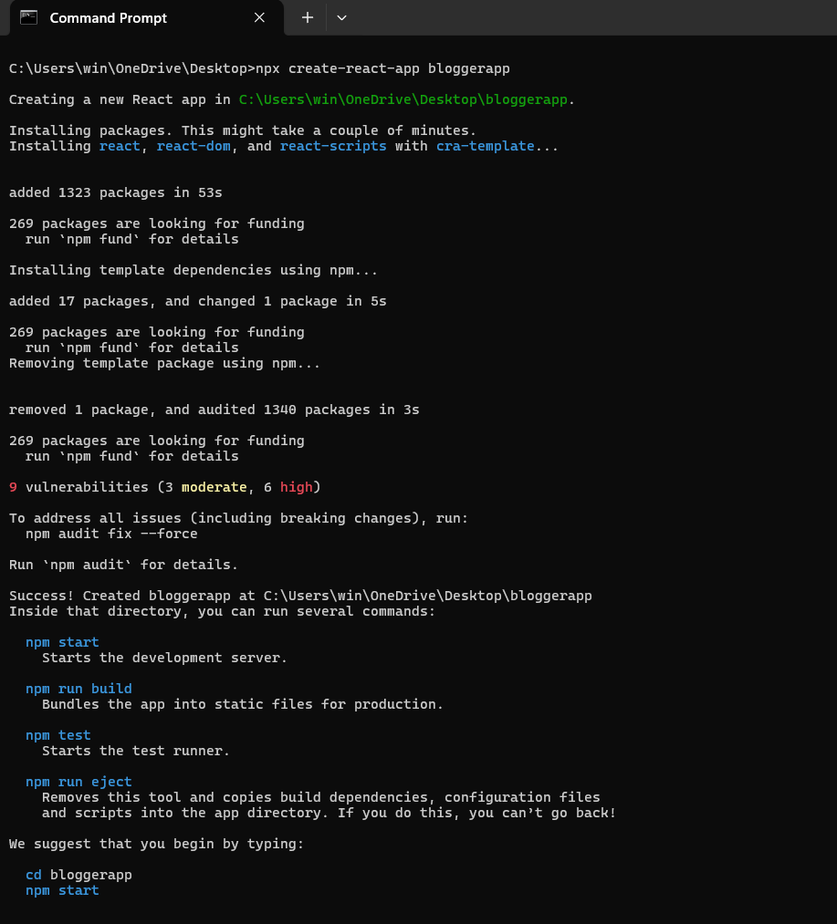

Step 2: Create Components
Create a new folder: src/components/
Inside that folder, create 3 files:
BookDetails.js
import React from 'react';

const BookDetails = () => {
return <h2>This is Book Details</h2>;
};

export default BookDetails;

BlogDetails.js
import React from 'react';

const BlogDetails = () => {
return <h2>This is Blog Details</h2>;
};

export default BlogDetails;

CourseDetails.js
import React from 'react';

const CourseDetails = () => {
return <h2>This is Course Details</h2>;
};

export default CourseDetails;

Step 3: Create book.js (src/data/book.js)
export const books = [
{ id: 101, bname: 'Master React', price: 670 },
{ id: 102, bname: 'Deep Dive into Angular 11', price: 800 },
{ id: 103, bname: 'Mongo Essentials', price: 450 },
];

Step 4: Update App.js
import React, { useState } from 'react';
import { books } from './data/book';
import './App.css';

function App() {
const [activeView, setActiveView] = useState('book'); // default is Book view

const bookdet = (
<ul>
{books.map(book => (
<li key={book.id}>
{book.bname} - ₹{book.price}
</li>
))}
</ul>
);

const content = (
<ul>
<li>React vs Angular</li>
<li>How to Write Clean Code</li>
<li>Why TypeScript Matters</li>
</ul>
);

const coursedet = (
<ul>
<li>Full Stack Web Dev</li>
<li>Data Structures in JS</li>
<li>React with Redux Toolkit</li>
</ul>
);

return (
<div className="App">
<h1>Blogger App</h1>

{/* BUTTONS TO CHANGE VIEWS */}
<div style={{ marginBottom: '20px' }}>
<button onClick={() => setActiveView('book')}>Show Book Details</button>
<button onClick={() => setActiveView('blog')}>Show Blog Details</button>
<button onClick={() => setActiveView('course')}>Show Course Details</button>
</div>

{/* 📘 CONDITIONAL RENDERING BASED ON activeView */}
{activeView === 'book' && (
<div className="st2">
<h1>Book Details</h1>
{bookdet}
</div>
)}

{activeView === 'blog' && (
<div className="v1">
<h1>Blog Details</h1>
{content}
</div>
)}

{activeView === 'course' && (
<div className="mystyle1">
<h1>Course Details</h1>
{coursedet}
</div>
)}
</div>
);
}

export default App;

Step5: Update App.css
.st2 {
background-color: #f9f9f9;
padding: 10px;
margin: 10px;
}
.v1 {
background-color: #e0f7fa;
padding: 10px;
margin: 10px;
}
.mystyle1 {
background-color: #f3e5f5;
padding: 10px;
margin: 10px;
}
button {
margin-right: 10px;
padding: 8px 12px;
font-weight: bold;
}

Step 6: Run the app
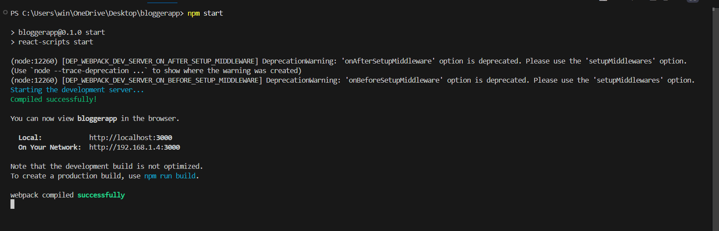
Output: 